**This is an answer page for section 2 of the Exam**

1. S3 bucket configuration:  
   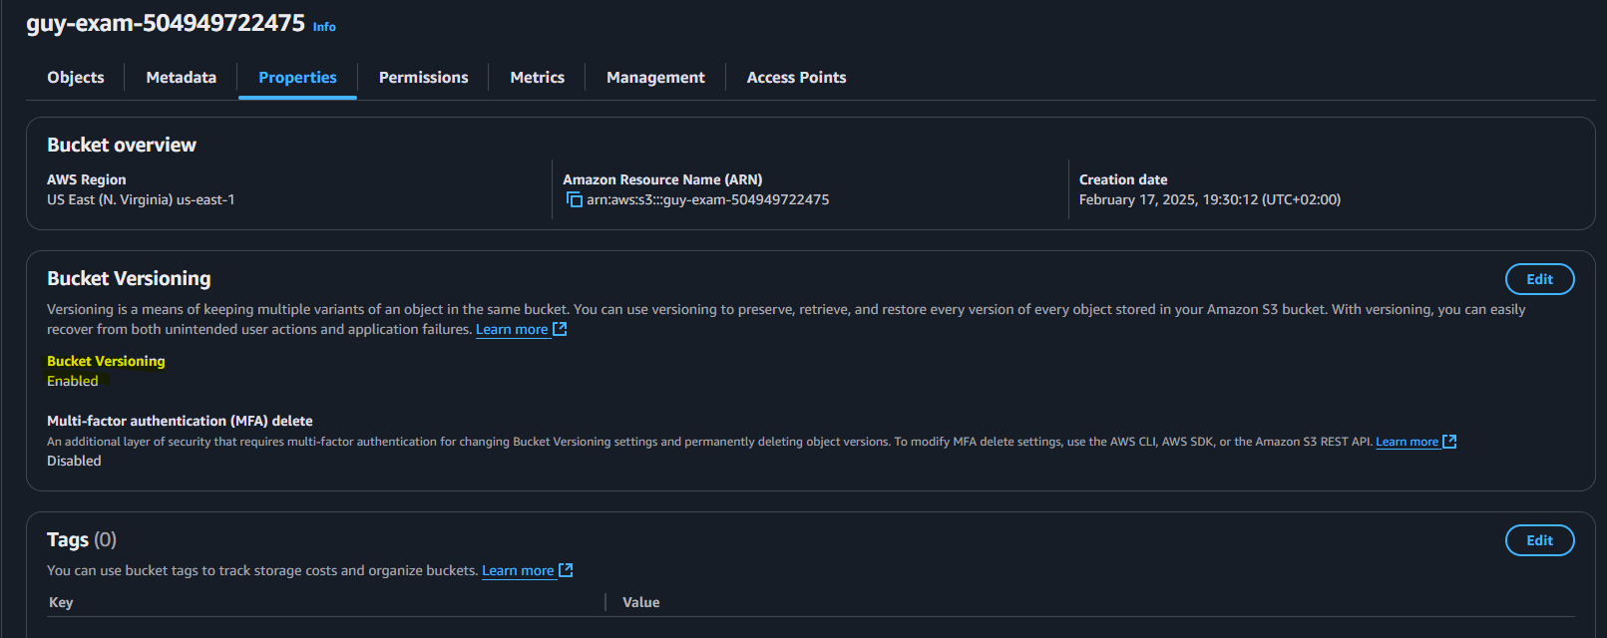 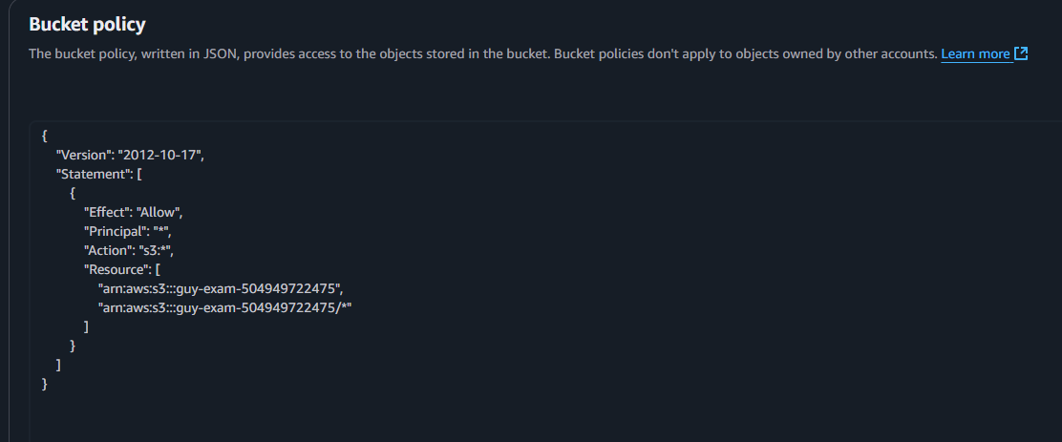
2. Launch an EC2 Instance:  
   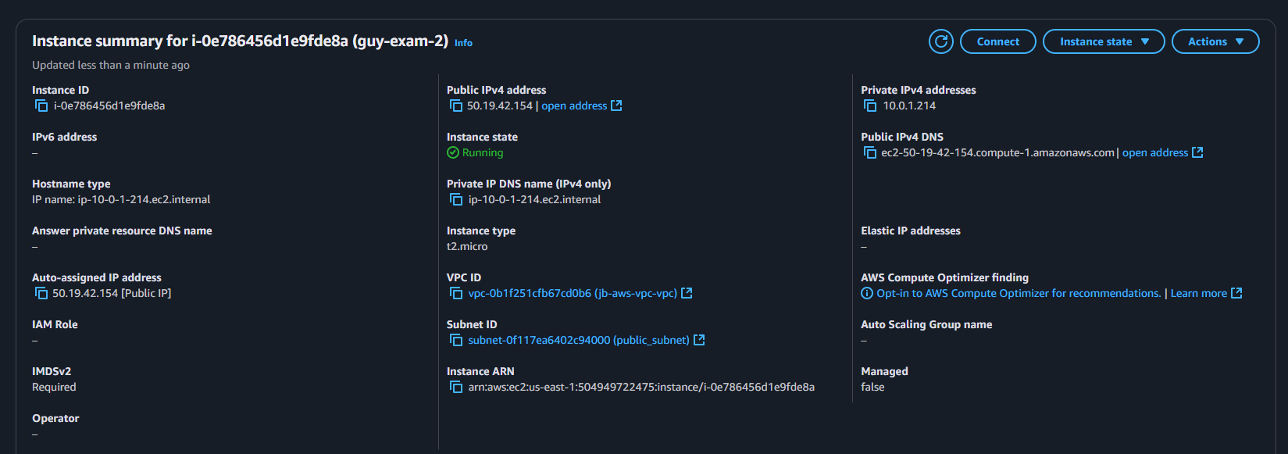  
   A screenshot of a computer

   AI-generated content may be incorrect.
3. Configure an IAM user with S3 access:  
   not working with JB account…
4. Set up a CloudWatch Alarm:  
   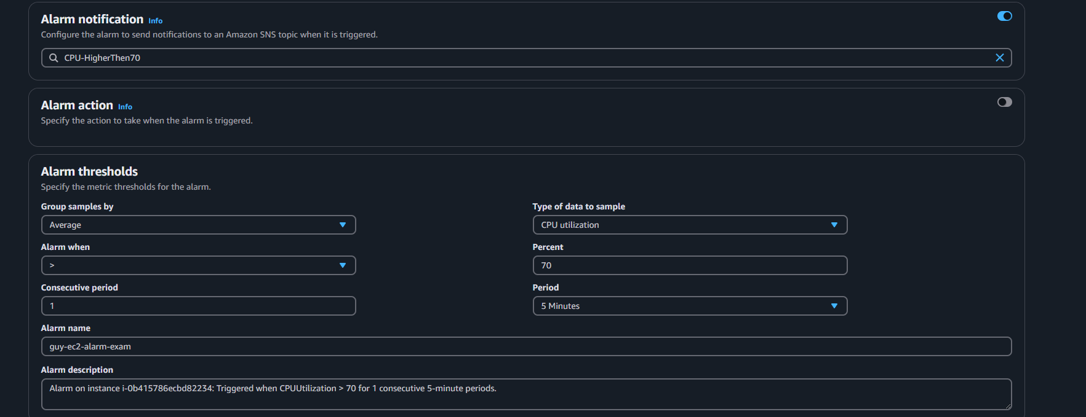 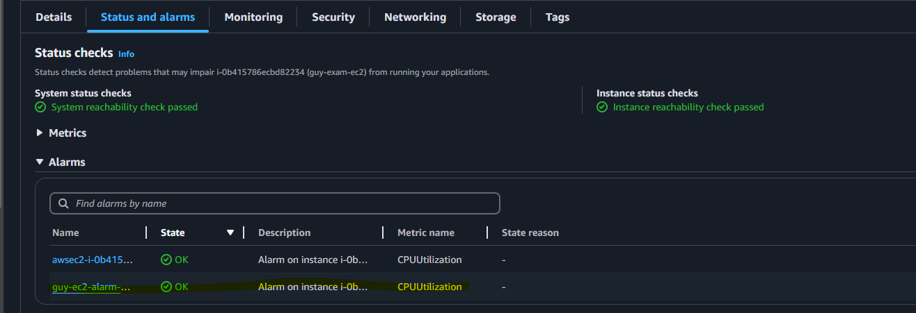 A screenshot of a computer screen

   AI-generated content may be incorrect.
5. Cost explorer:  
   forecast  
   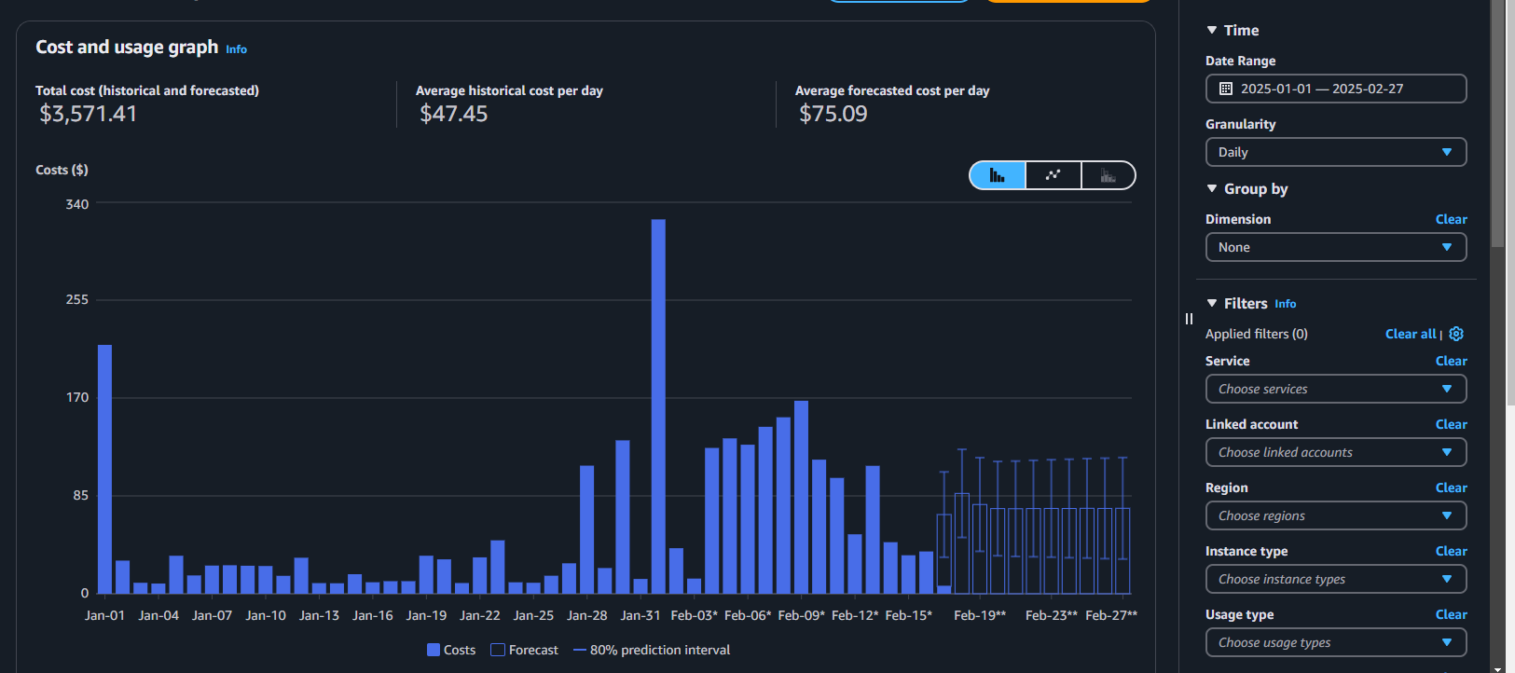  
   by selecting a future date, the service can forecast the cost while the “Show forecasted values” is checked in the bottom right corner (need to scroll down)

**Section 3: Hands-on advanced  
  
  
1. Auto scaling group with single EC2 Instance:  
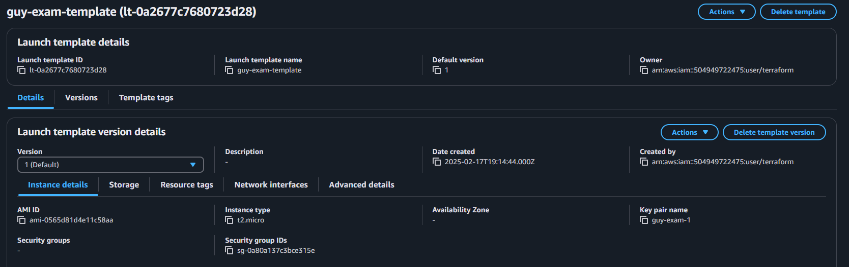  
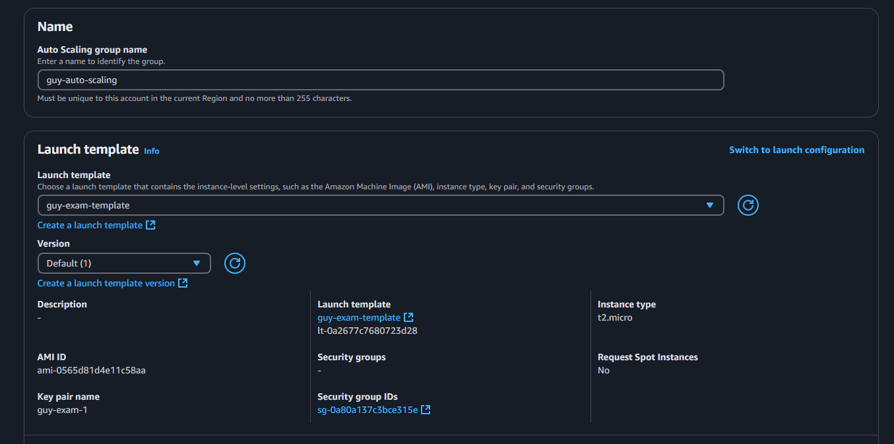 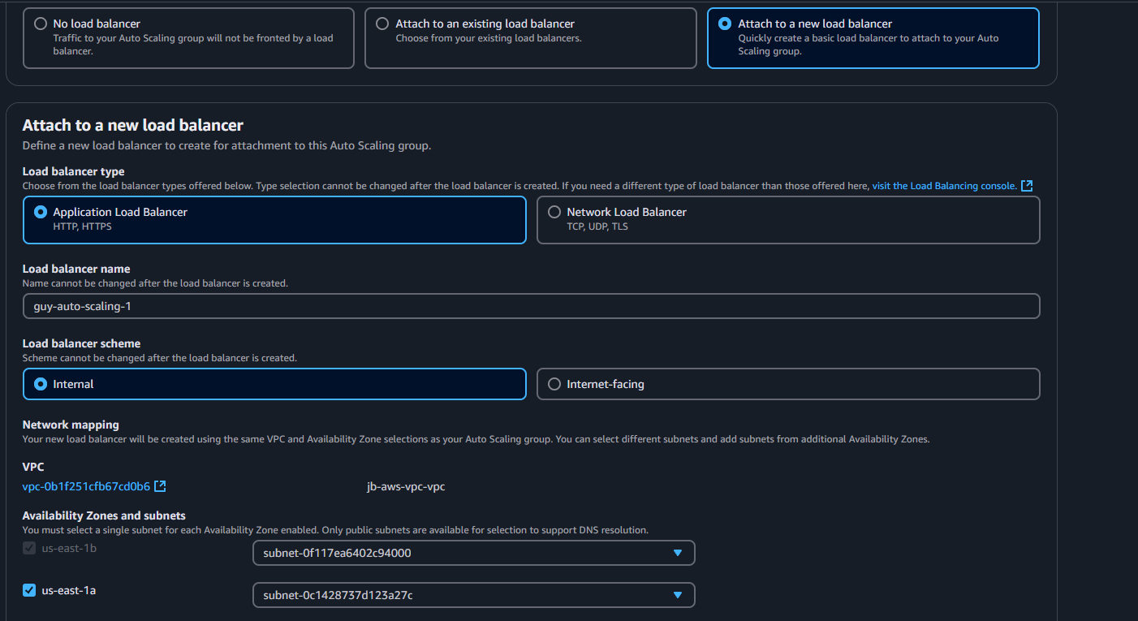 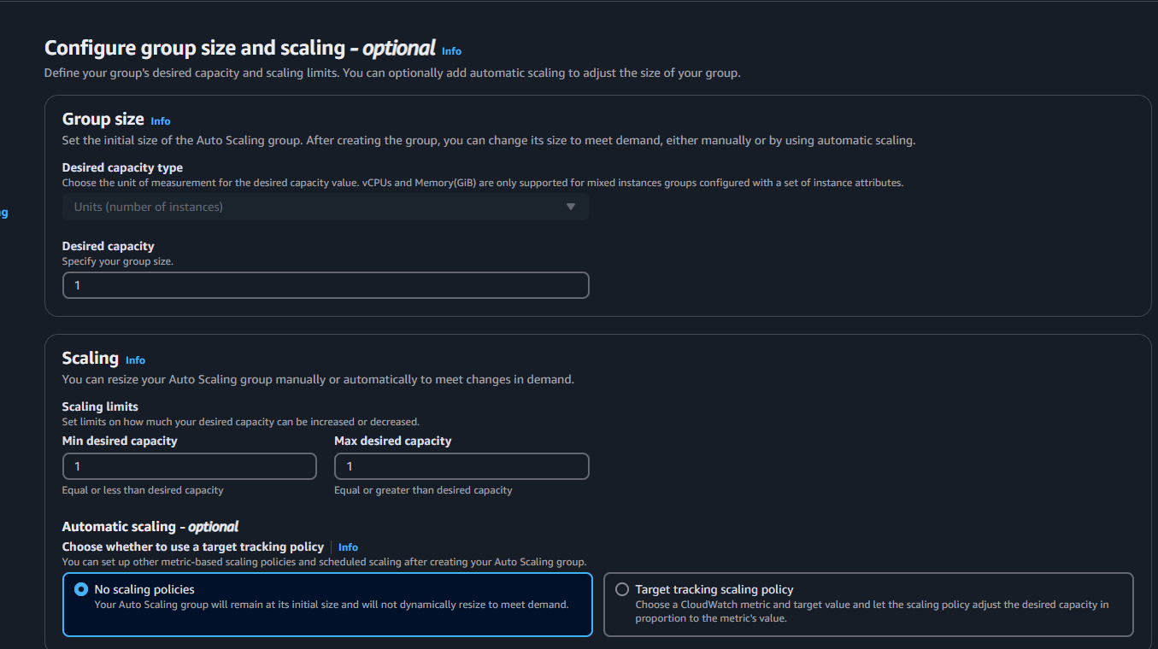 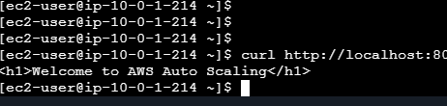 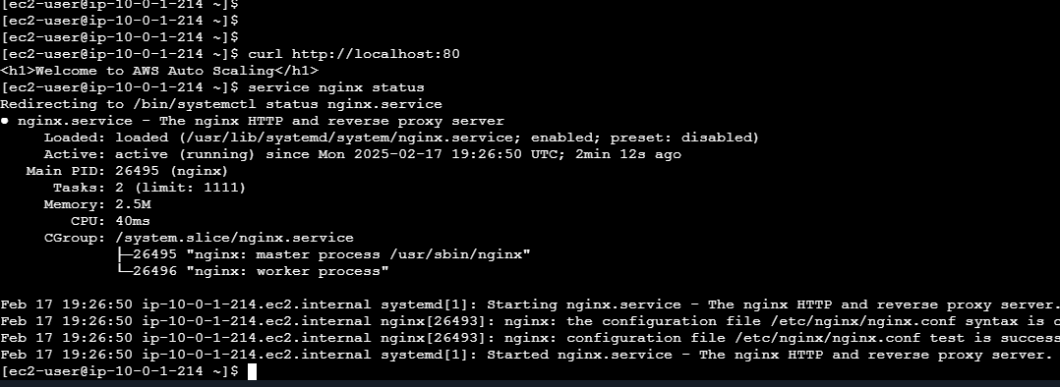

3.Access the web page via the load balancer:

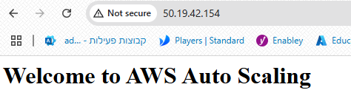 

4. IAM Usert Setup for S3 Access:  
can’t create users or assinge policys with JB teraform account

1. **Create a cloudwatch alarm for CPU usage:  
   